Looking For CDL Training?

Are you a Returning Citizen?

We Can Help!!

The

Office on Returning Citizen Affairs

www.orca.dc.gov
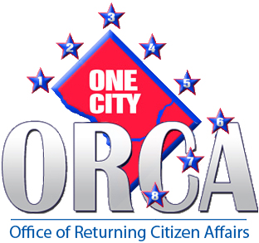

Visit our Office

At

2100 MLK Ave SE

Suite 301

We Have FREE CDL Training!!!!!

TODAY!!!!!!

