CDL CLASS B TRAINING

REQUIREMENTS TO TAKE CDL CLASS B TRAINING AT MORCA YOU MUST HAVE THE FOLLOWING DOCUMENTS:
- VALID DRIVER’S LICENSE
- 3-5 YEAR DRIVING RECORD
- RESUME
- DOT PHYSICAL CARD

CDL Class B Training is held twice (2) monthly on a first come first served basis.
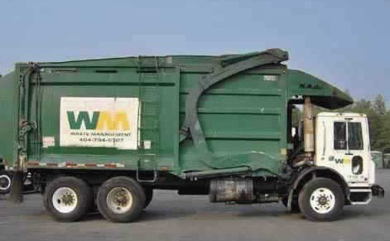 SEE ATACHMENTS FOR PROVIDERS

LIST OF PROVIDERS FOR DOT PHYSICAL
Provider: Amy Nassar (Minute Clinic)
Location: 845 Bladensburg Rd NE, Washington, DC 20002
Telephone: 1-866-389-2727
Appointment must be made for physical
Cost: $137.00

Provider: Marianne Knue (Minute Clinic)
Location: 1275 Pennsylvania Ave, Washington, DC 20004
Telephone: 1-866-389-2727
Appointment must be made for physical
Cost: $137.00

Provider: Robert Yancey
Location: 3120 Georgia Ave NW, Washington, DC 20010
Telephone: 202-722-0122
Hours of Operations: M-F 7:00am-3:00pm Sat 7:00am-11:00am (Walk-ins only)
Cost: $40.00

Provider: Jackson L. Davis & Juanita Archer
Location: 4121 Minnesota Ave NE, Washington, DC 20019
Telephone: 202-388-6001
Hours of Operations: Tues/Thurs/Fri 9:00am-2:30pm (Walk-ins only)
Cost: $77.12

Provider: Kristie Quarles (Unity Health Care)
Location: 3240 Stanton Rd SE, Washington, DC 20020
Telephone: 202-889-3754
Hours of Operations T/TH 7:00am-7:00pm, Weds 7:00 am-11:00am (Appointment Only)
- All insurance is accepted
- If uninsured cost will come out of pocket but sliding scale fee is depending on family size and income you will have to provide proof of income and family size is required

LIST OF PROVIDERS FOR DOT PHYSICAL

Provider: Lisa Covel (Unity Health Care)
Location: Brentwood Health Center, 1251 B Saratoga Ave NE, Washington, DC 20018
Telephone: 202-832-8818
Hours of Operations: T/TH 7:00am-7:00pm, Weds 7:00am-11:00am (Appointment Only)
- All insurance is accepted
- If uninsured cost will come out of pocket but sliding scale fee is depending on family size and income you will have to provide proof of income and family size is required

Provider: Haileleoul D. Erbello (Metro Lab)
Location: 3422 Gerogia Ave NW, Washington, DC 20010
Telephone: 202-234-1234
Hour of Operations: M-F 9:00am-5:00pm (Walk-ins)
Cost: $50.00

Provider: Gina Pervall
Location: 2141 K St NW, Washington, DC 20037
Telephone: 202-758-0559
Hours of Operation: Mon, Tues, Weds, and Fri 8:30am-4:30pm Thurs 9:30-5:30 (Appointment Only)
Cost: $90.00

CDL DMV asFEES:

CDL Learner’s Permit Cost: $78.00
CDL License Cost: $117.00
Commercial Driver’s License Endorsement Cost: $20.00 for each endorsement
CDL Knowledge Test: $10.00
CDL License Road Test: $10.00

Please contact Ms. Jackson if you need further information at (202) 715-7675 or alicia.jackson2@dc.gov

